

**Dream Travel Agency**

**Group Members:**

|  |  |
| --- | --- |
| **Name** | **Roll No.** |
| Awais Aleem | 223 |
| Ahmed Bilal | 207 |
| Rana Abdullah | 196 |
| Ahmad Raza | 228 |
| Ahsan Abdullah | 213 |

**Course:**

AICTL

**Instructor Name:**

Ramsha Khalid

**Date:** 29/12/2025

**Executive Summary:**

Dream Traveler Agency is a static travel-agency website developed using **HTML and CSS**. The website is designed to promote travel services, tour packages, and customer engagement through a clean and attractive layout. The project focuses on front-end design, proper site structure, and visual consistency while applying basic web-development concepts learned during the course.

**Project Objectives & Scope:**

**Objectives**

* To design a professional travel agency website
* To practice HTML page structure and CSS styling
* To improve UI design and navigation skills

**Scope**

* Static website only (no backend)
* Travel information and service presentation
* Desktop-responsive layout
* Educational project for learning purposes

**Site Structure & Navigation:**

|  |  |
| --- | --- |
| **Page Name** | **Purpose** |
| Home | Introduction to Dream Traveler Agency |
| Packages | Travel packages and offers |
| Services | Agency services |
| Gallery | Showing the pictures of other country |
| Contact Us | Contact form and details |

**Design Choices:**

**Fonts**

* Headings: ‘**Poppins’ / Sans-Serif**
* Paragraph text: ‘**Poppins’ / Sans-Serif**

**Colors**

We use the contrast of **Pink** and **it’s variation**.

**Layout Decisions**

* Sticky header navigation
* Hero section on home page
* Card-based package design
* Flexbox and grid layout for responsiveness

**Assets Used:**

**Images**

* Travel destination images
* Background banner images
* Service icons
* Google map

**Sources**

* Free stock images (Unsplash / Pexels)
* Free icons (Icon libraries)

**Exact figures used later**

* Total images used: **28**
* Total icons used: **7**

**How to Run / Publish the Site**

* Open the project folder
* Double-click **home.html**
* The website opens in a web browser

OR

* For publishing, upload all HTML, CSS, and asset files to a static hosting service such as GitHub Pages, Netlify, or any web hosting platform supporting static files.
* Ensure relative paths to images and CSS files are correctly maintained.
* The live URL for the deployed site is: [**https://iawaisaleem.github.io/Group_06-Dream-Traveler-Agency/**](https://iawaisaleem.github.io/Group_06-Dream-Traveler-Agency/)

QR Code of Website:

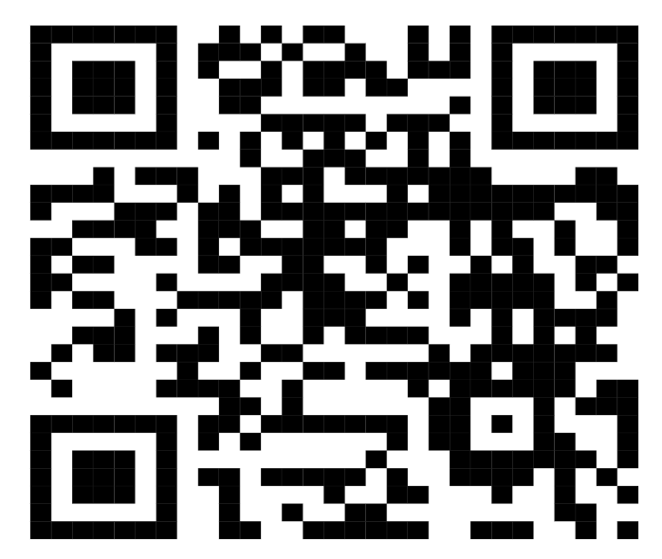

**Screenshots:-**

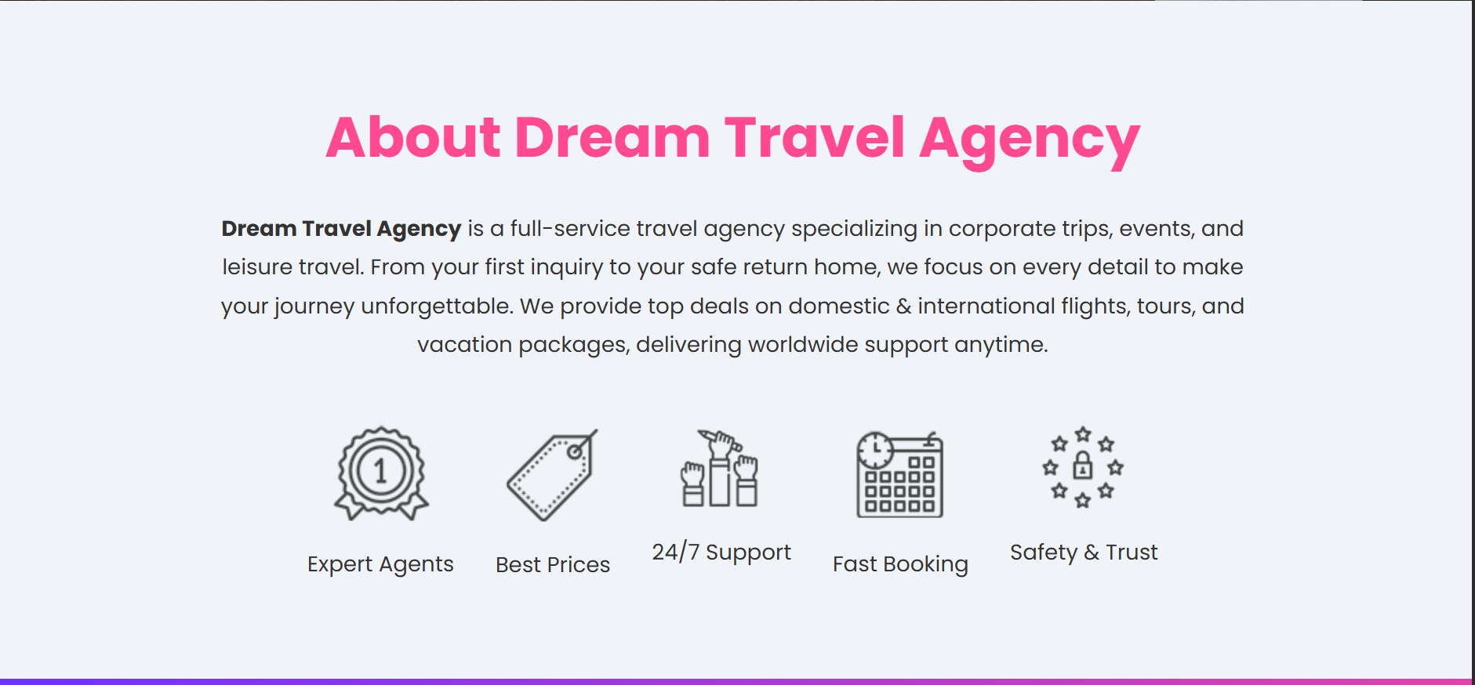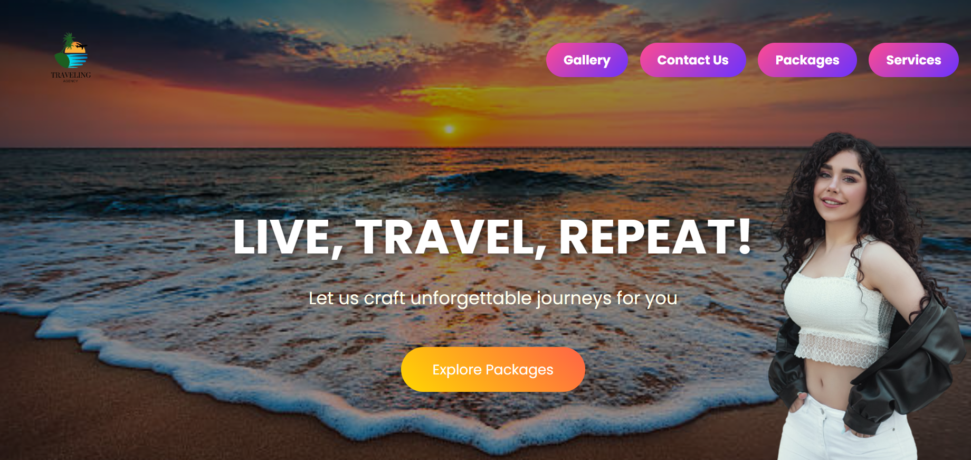**Home:**

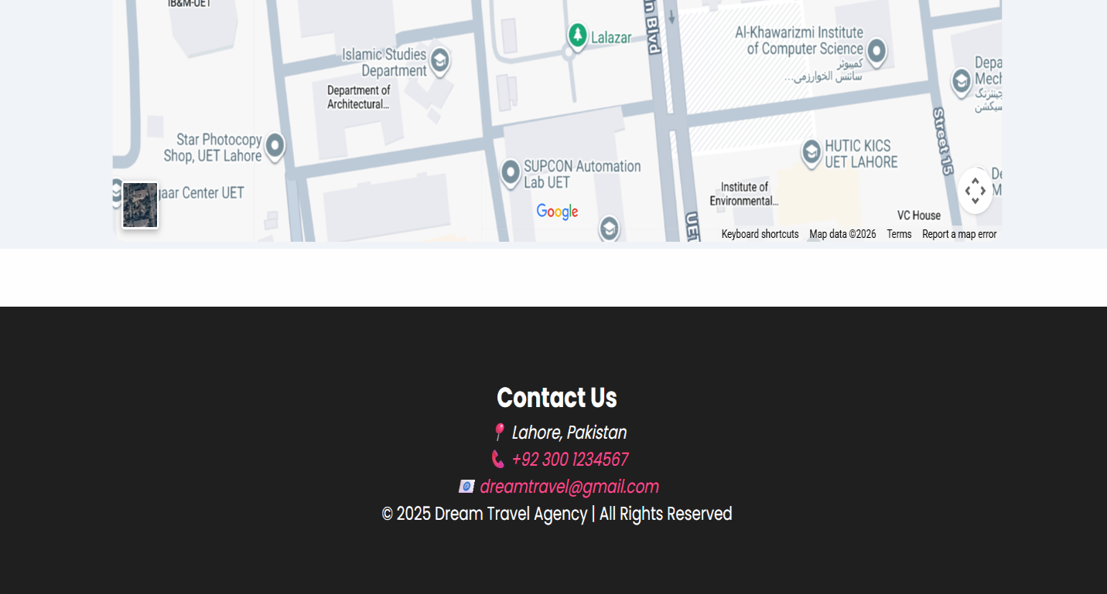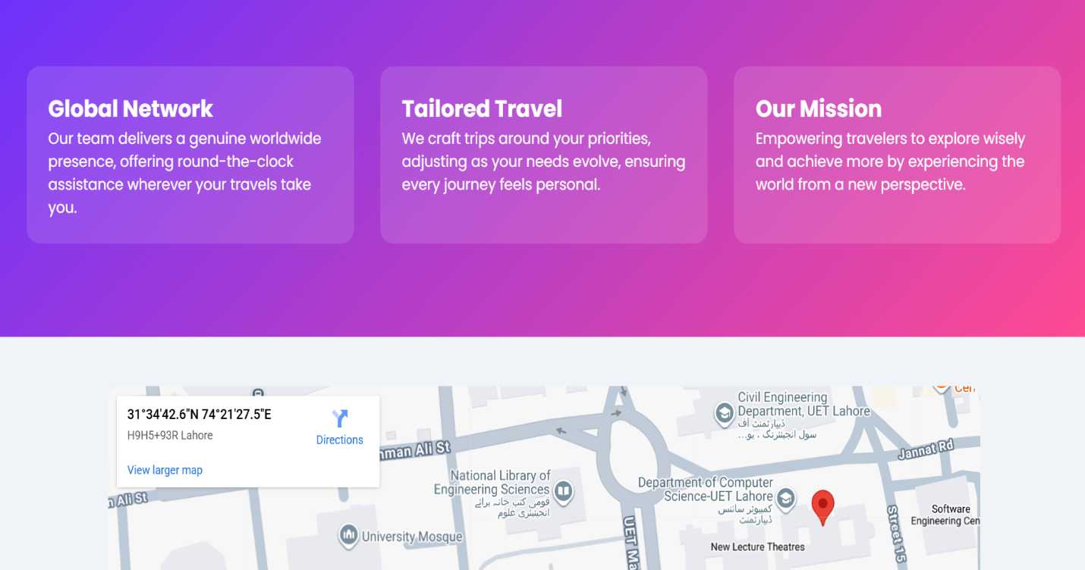

**Gallery:**

* Aisia-Section:

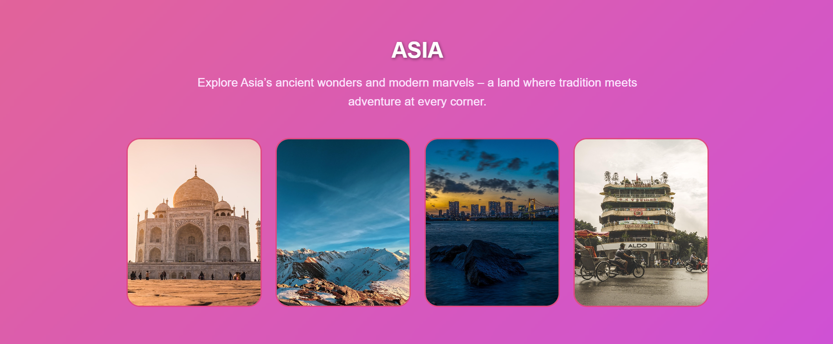

In photots when you move cursor it changes pictures.

* Europe-Section:

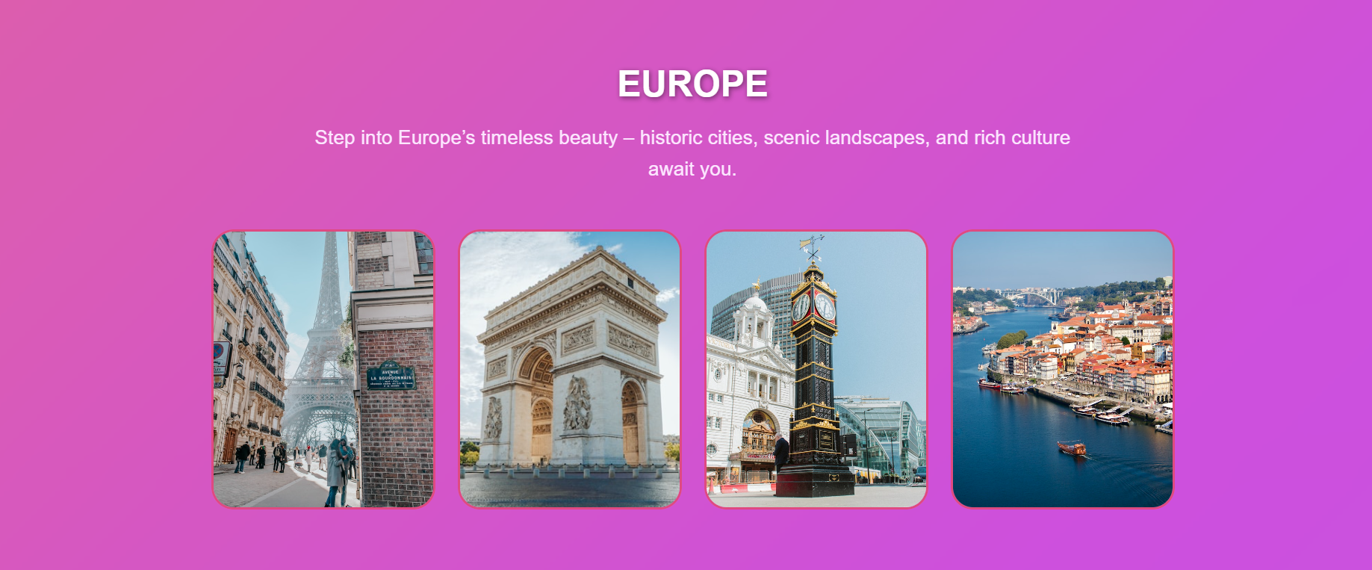

In photots when you move cursor it changes pictures.

* Africa-Section:

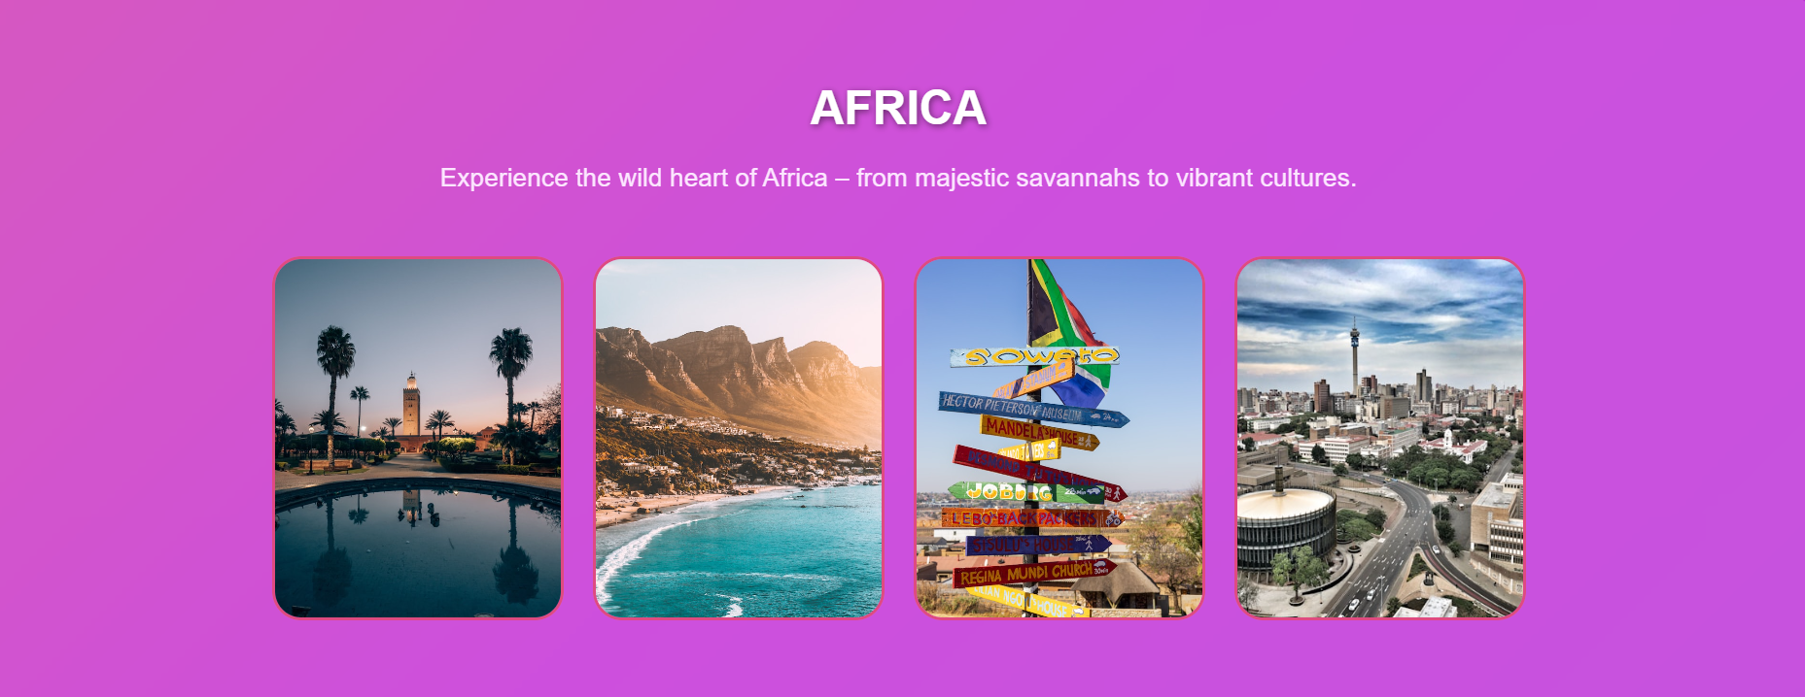

In photots when you move cursor it changes pictures.

* North & South America-Section:

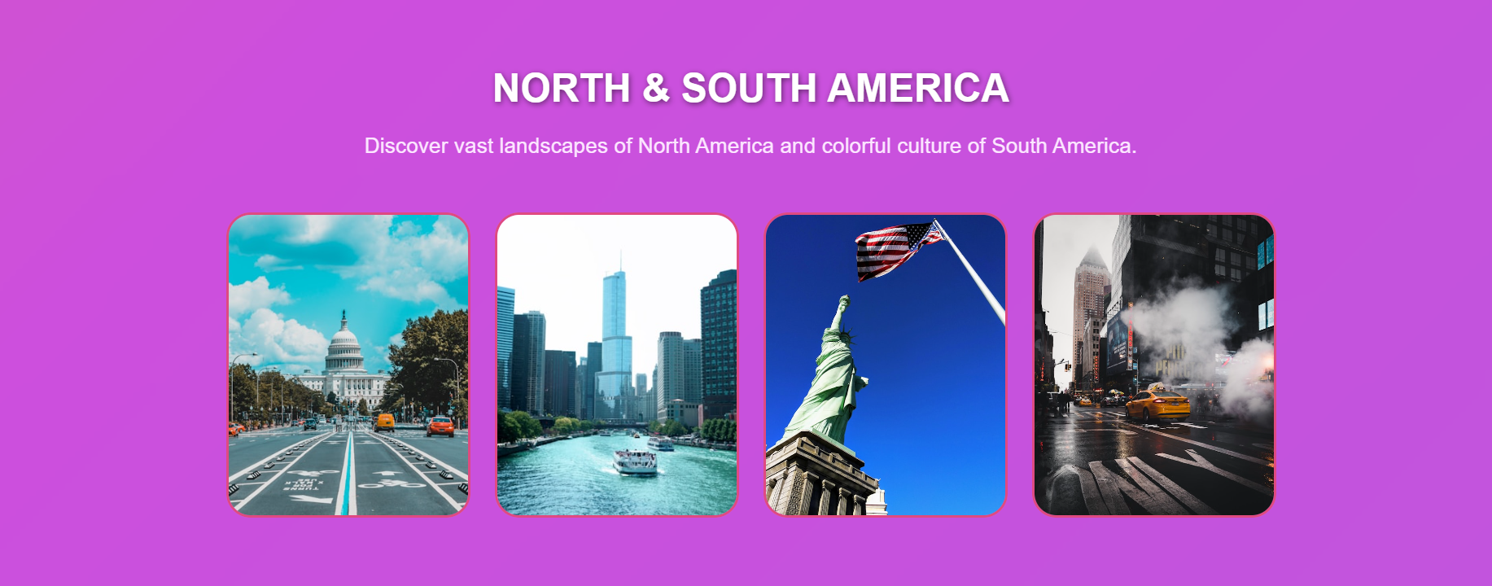

In photots when you move cursor it changes pictures.

* Aurstralia & Oceania-Section:

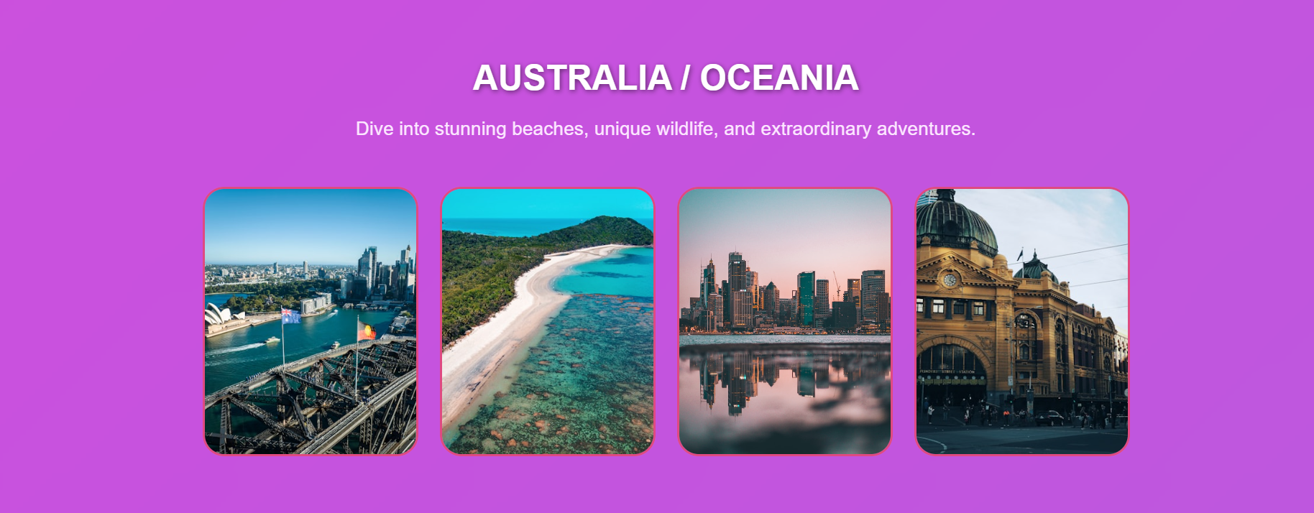

In photots when you move cursor it changes pictures.

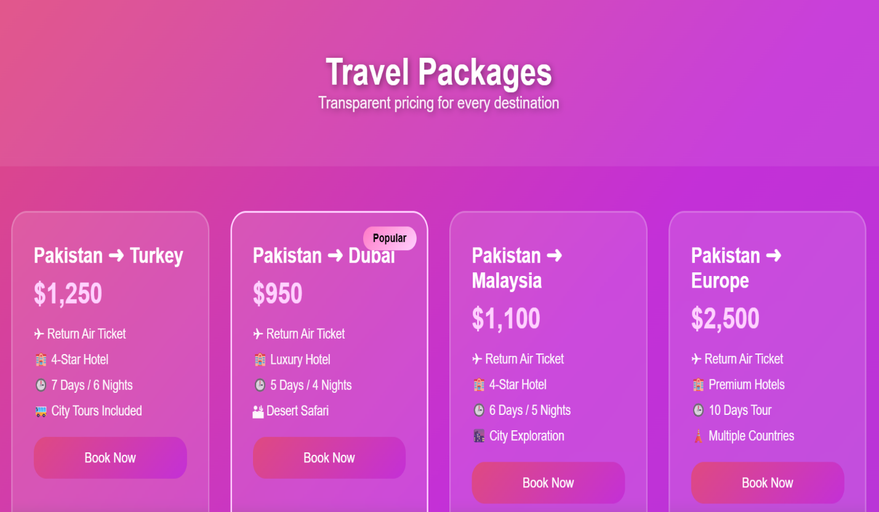**Packages:**

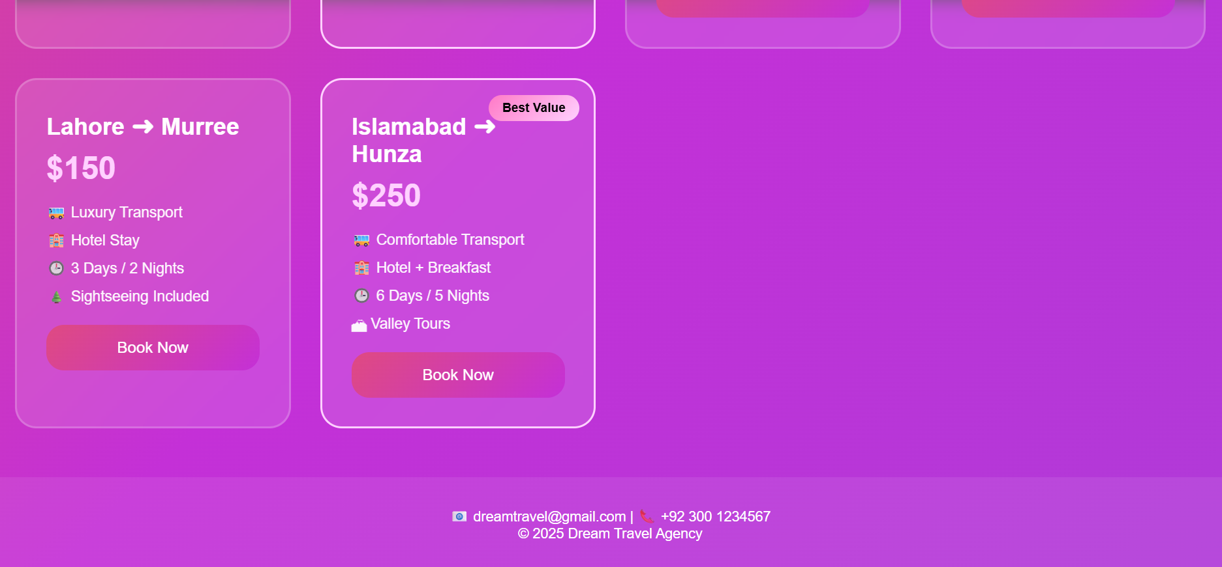

When you on Book now the page take you in contact us button

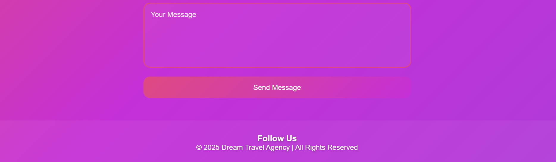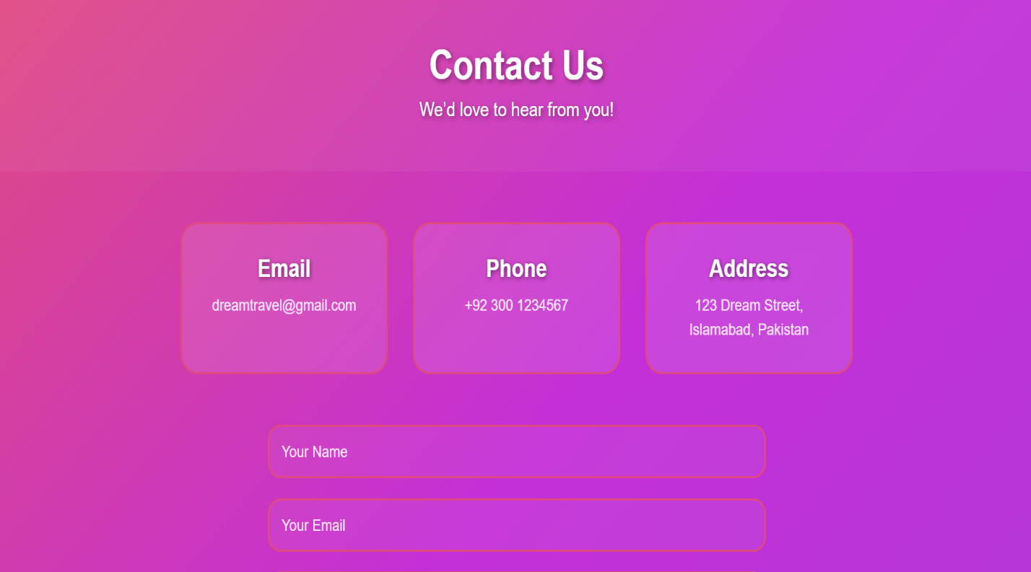**Contact Us:**

* Through this page you can contact with agent.

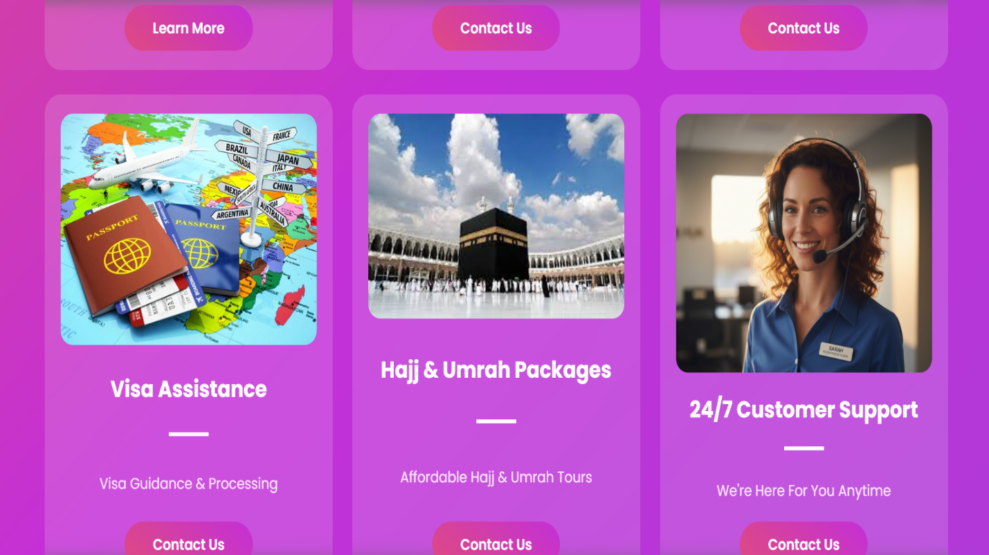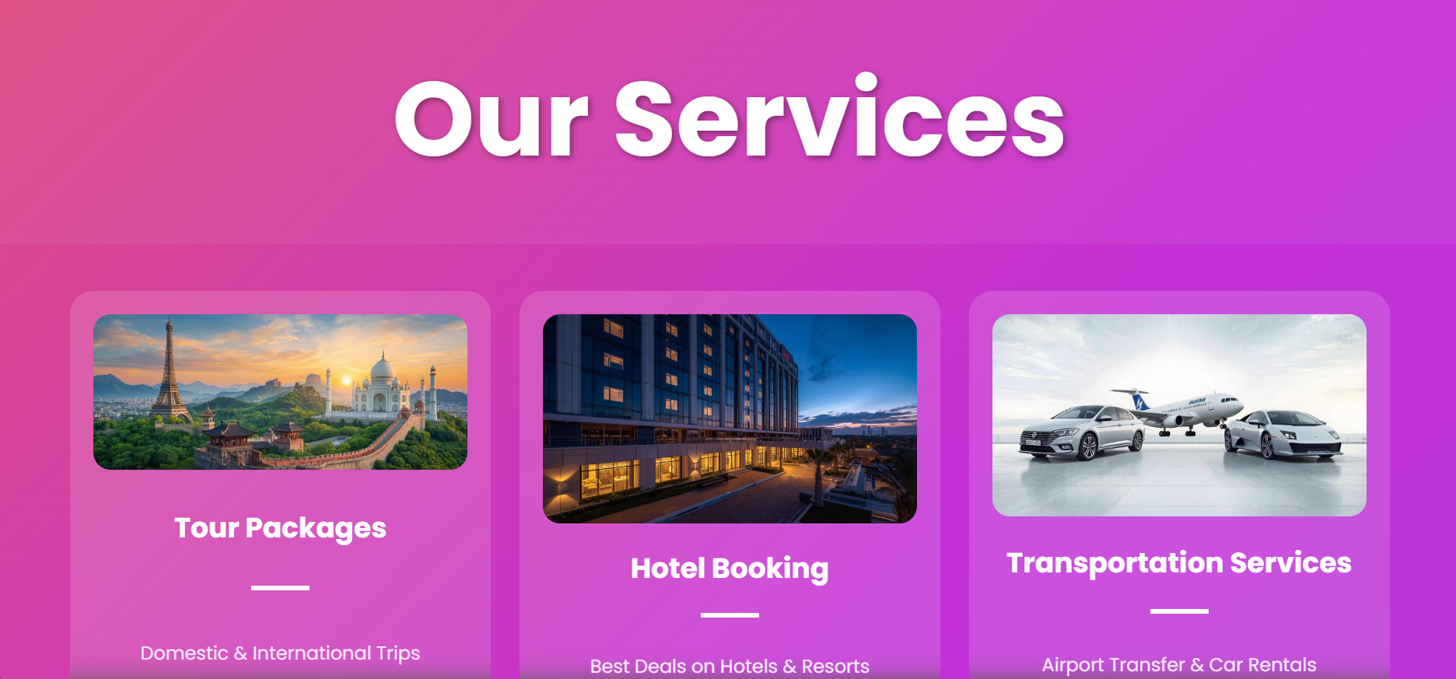**Our Services-Section:**

* When you click on Buttons, the page take you in another page

**Chart:**

* This chart is from Excell which shows the **prices** of different tours

**Reflection**

This project helped us understand how to structure a website using HTML and style it effectively using CSS. We learned layout techniques, color selection, and responsive design basics. In the future, the website can be improved by adding JavaScript for interactivity and a backend for booking and user data storage.